Source Control Method & Approach
Jmr Reference

Summary Source control is a central element in secure file storage, transfer, sharing and use. It is also really damn easy and quick when practiced right, cross platform too. The following doc illustrates this with the intent of promoting wide & uniform use.
Author Justin Reina
Date 10/21/17

Platform Coverage  - Windows  - Linux  - Macintosh  Repository Location  - Local, stored only on your computer  - e.g. on 'C:\' drive  - Remote, stored on an external server  - e.g. GitHub | Software Selection  - terminal (Win: Cygwin/Linux:tty/  - git Mac:Terminal)  - gitk  Auxillary Interface  - GitHub Desktop  - GitHub Web  - IOS CodeHub  Useful & Recommended  - Cygwin (Windows Bash Terminal)  - Eclipse (Git & Team Viewer Views)

Base Intent
- Track all revisions & changes
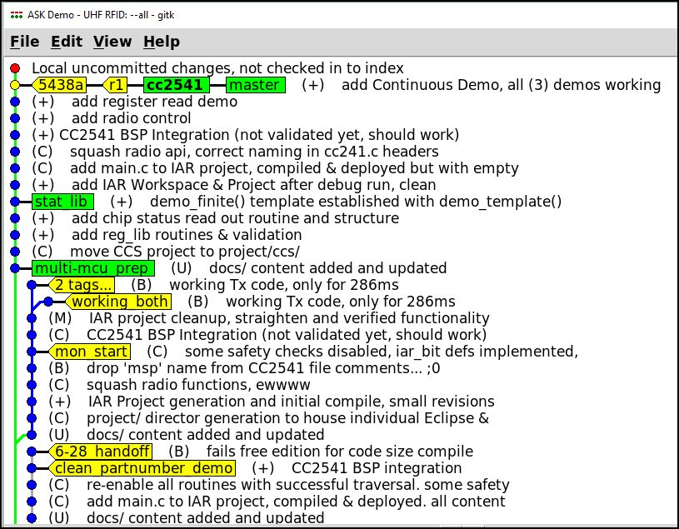Figure 1: Example Repository
- Tag & track releases
- Tag & track development
- Dev ideas (e.g. a new feature,
debugging an issue, etc.)

Example (Jmr, ASK Ref Project)
The example shown in Figure 1 illustrates:
- Tags(yellow) – tracking
  - e.g. ‘r1’ for rev 1, released to team
  - e.g. ‘6-28_handoff’ for last handoff

- Branches (green) – development
  - e.g. ‘stat_lib’ for the statistics dev

- Form & Structure – type of commit
  - ‘(+)’ – “Addition”
  - '(C)’ – “Change”
  - ‘(B)’ – “Bug”
  - ‘(M)’ – “Misc.”
  - ‘(U)’ – “Update”
  - ‘(*)’ – “Unknown”
Table of Contents
A 3
B 4
C 5

A

B

C

